Given an array of points where points[i] = [xi, yi] represents a point on the **X-Y** plane and an integer k, return the k closest points to the origin (0, 0).

The distance between two points on the **X-Y** plane is the Euclidean distance (i.e., √(x1 - x2)2 + (y1 - y2)2).

You may return the answer in **any order**. The answer is **guaranteed** to be **unique** (except for the order that it is in).

**Example 1:**

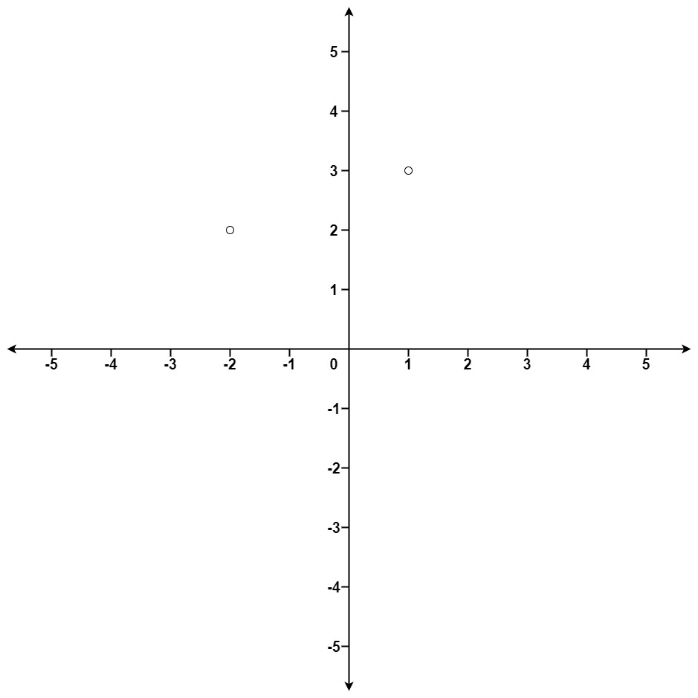

Input: points = [[1,3],[-2,2]], k = 1  
Output: [[-2,2]]  
Explanation:  
The distance between (1, 3) and the origin is sqrt(10).  
The distance between (-2, 2) and the origin is sqrt(8).  
Since sqrt(8) < sqrt(10), (-2, 2) is closer to the origin.  
We only want the closest k = 1 points from the origin, so the answer is just [[-2,2]].

**Example 2:**

Input: points = [[3,3],[5,-1],[-2,4]], k = 2  
Output: [[3,3],[-2,4]]  
Explanation: The answer [[-2,4],[3,3]] would also be accepted.

**Constraints:**

* 1 <= k <= points.length <= 104
* -104 <= xi, yi <= 104